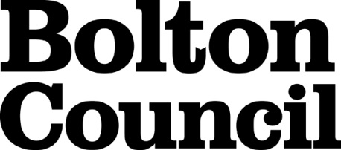
Bolton Library and Museum Learning

School Visit Enquiry Form

Please do not book your coach until you have received email confirmation from us

Your contact details:

School Name
Address
Postcode
Contact Name
Contact Email
Contact Number

Which workshop do you require?

Bolton Central Museum KS2
Egypt (at the Museum) | ☐ | Tropical Rainforest Quest | ☐
Arty Explorers | ☐ | Local History Investigators | ☐
Museum on Tour (at your School) | ☐
Bolton Central Museum Early Years/ KS1
My First Trip To A Museum | ☐ | Dinosaur Discovery | ☐
Childhood in Bolton | ☐
Other (please give details)

Dates – please give three preferred dates and indicate morning or afternoon.
 | Date | AM | PM
1 |  | ☐ | ☐
2 |  | ☐ | ☐
3 |  | ☐ | ☐

Your group

Number of children |  | Year of group
Any other information – access information, different/special needs of group, school hall availability etc.

You will receive an email from us to confirm the date, time, cancellation policy and, if applicable, the cost of your workshop. Please do not make any transport (or other) arrangements until you have received your confirmation email.

Please return this form to: SLMS@bolton.gov.uk

