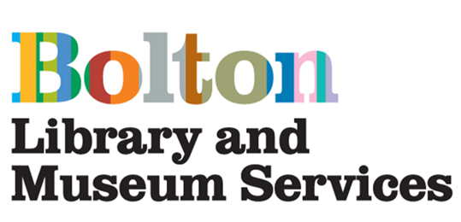
Bolton Library and Museum
Youth Forum Application

Are you aged between 14 & 21?

Would you like to help shape the future of Bolton Library and Museum?

Bolton Library and Museum Service are seeking a team of Young People to collaborate with us and share ideas of how we can improve our Library and Museum.

This opportunity will enable you to share your views on how we can transform our building and the services we provide for Young People.

Our Library and Museum has been selected to receive investment from the National Towns Fund scheme and we would like you to help ensure future developments are relevant and engaging to younger members of Bolton’s community.

We will meet approximately every 4-6 weeks, starting Summer 2021.

Be part of this opportunity to help shape the future of our Library and Museum!

You don't have to have done anything like this before. If it sounds like you'd like to give it a go, just fill out the form below.

Name _________________________________________________

Age _____________

Address _________________________________________________________________

Postcode _____________________

Email __________________________________________________________________

Telephone Number _____________________________

Why would you like to be part of the Bolton Library & Museum Youth Forum?

References
Please give the name, phone number and email address of a person we can contact as a referee to comment on your suitability be part of the Youth Forum. A referee cannot be a family member.

Name __________________________________

Phone number ____________________________

E-mail __________________________________

Please return this form to the Youth Forum Co-ordinator at Bolton Library & Museum, Le Mans Crescent, Bolton, BL1 1SE or email it to blamsvolunteering@bolton.gov.uk by 23rd May 2021.

